Analysis on foreign football players in the top 5 European leagues
Danny apsel

2025

1. Introduction 2
2. Data scrapping 2
3. Data Analysis 3
3.1. Bosman ruling 3
3.2. Premier League 3
3.3. La Liga 5
3.4. Serie A 7
3.5. Bundesliga 9
3.6. Ligue 1 10
3.7. Big 5 combined 12

Introduction
Growing up, football was always more than just a game to me—it was a source of unforgettable memories and excitement. One of my earliest and most vivid experiences was watching the 2010 World Cup final. Although I was only allowed to see the first half at summer camp, a twist of fate led me to the infirmary, where I witnessed Andrés Iniesta’s iconic goal in extra time. The energy in the room and the collective celebration made me realize just how powerful and unifying football can be. Inspired by moments like these, I decided to explore the evolution of player nationalities in Europe’s “Big 5” leagues. This report analyses historical trends, highlights the rise of football as a global sport, and examines how the movement of players reflects broader patterns in the world today.

Data scrapping
For this project, I sourced my data from fbref.com, a well-known football statistics website that provides comprehensive historical data on player nationalities for Europe’s “Big 5” leagues. The coverage starts from 1988 for the Bundesliga, La Liga, and Serie A, from 1992 for the Premier League, and from 1995 for Ligue 1. This made fbref.com an ideal source for analysing long-term trends in player nationalities.
To extract the data, I used Python’s pandas library, specifically the read_html function, which allows for direct scraping of HTML tables from web pages. For each season, I constructed the appropriate URL and read the nationality table into a DataFrame. However, I quickly encountered a limitation: fbref.com restricts automated requests, and making too many requests in a short period resulted in an “access denied” error. To work around this, I implemented a manual delay of 10 seconds between requests for each season. While this made the process slower, it ensured that I could collect the data for every year without being blocked by the website.
Once the raw data was collected, I saved each season’s nationality table as a CSV file. The next step was data cleaning. Using pandas, I removed unnecessary columns and set the appropriate indices to make the data easier to work with. I then created two main DataFrames: one showing the number of players from each country per season, and another showing the total minutes played by players from each country per season. In both cases, countries are represented as rows, years as columns, and the values indicate either the number of players or the total minutes played.
During the cleaning process, I encountered several discrepancies and edge cases. For example, some countries that existed in the past, such as Yugoslavia or the USSR, no longer exist today. Where possible, I assigned players to their modern successor states (e.g., Croatian players who previously appeared under Yugoslavia are now counted under Croatia). If a country no longer exists in any form, it was kept as a separate entry. This means that, for some countries—especially those from the Balkans—the historical data may not perfectly align with current national boundaries. Additionally, fbref.com lists players from the United Kingdom as separate entities: England, Scotland, Wales, and Northern Ireland. I maintained this distinction in my analysis to remain consistent with the source data.
Another challenge was dealing with inconsistencies in country names and handling years where data might be incomplete or formatted differently. I standardized country names where necessary and ensured that missing values were handled appropriately, either by filling them with zeros or by excluding incomplete records.
Overall, the data scrapping and cleaning process required careful attention to detail and a flexible approach to handle the quirks of historical football data. The resulting dataset provides a robust foundation for analysing how the composition of Europe’s top leagues has evolved over time, and it highlights some of the complexities involved in working with real-world sports data.

Data Analysis

Bosman ruling
The Bosman ruling, established in 1995 by the European Court of Justice, revolutionized football by granting players greater freedom of movement. Named after Belgian footballer Jean-Marc Bosman, the ruling allowed players in the European Union to transfer to another club without a transfer fee once their contract expired. It also abolished quotas on foreign EU players in domestic leagues, fostering a more open and competitive football market. This decision significantly impacted player rights, club strategies, and the globalization of football.

Premier League
The Premier League, founded in 1992, is the top tier of English football. Before its rebranding, it was known as the First Division under the Football League. Unlike other UK leagues, the Premier League includes only English clubs, excluding teams from Wales, Scotland, and Northern Ireland. Today, it is widely considered the strongest football league in the world, known for its competitiveness and global appeal. Major clubs such as Manchester City, Liverpool, and Arsenal consistently perform at the highest level, attracting talent and fans from around the globe.
The following graphs shows the number and percentage of the top 10 foreign player nationalities playing in the Premier League.
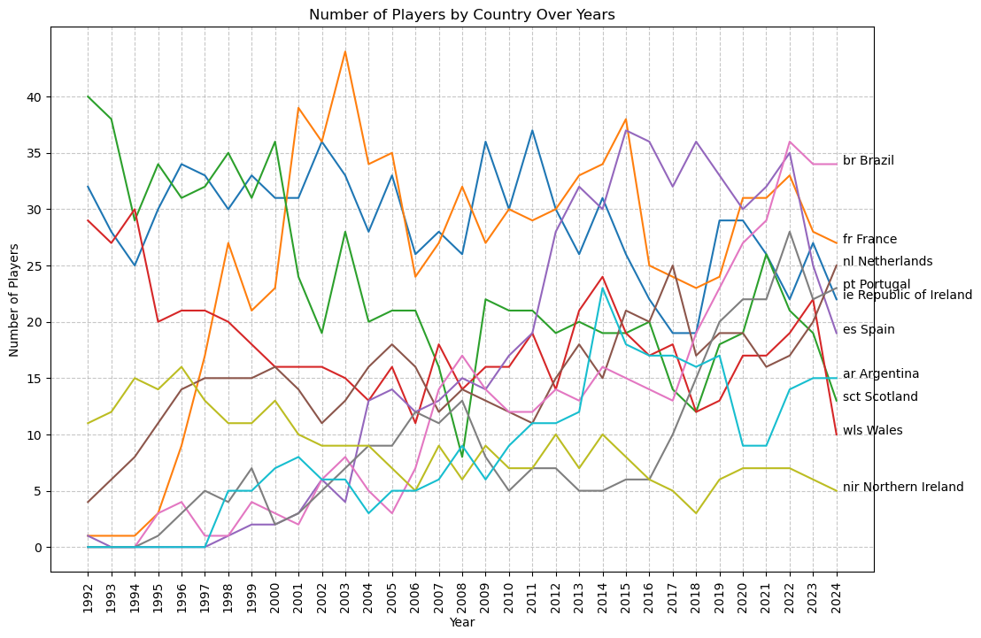
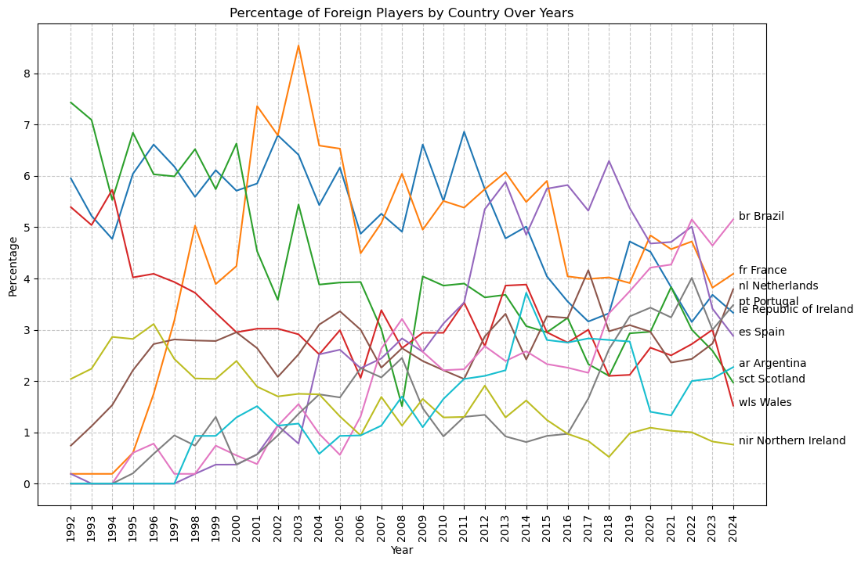
Prior to the 1995 Bosman Ruling, the only non-English players were from the other UK nations (Wales, Scotland, Northern Ireland) plus the Republic of Ireland, which benefited from the longstanding Common Travel Area agreement.
After the Bosman ruling, the number of foreign players quickly rose, with countries like France having over 40 players represented in 2004. In the early-to-mid 2010s, the period of Spanish clubs’ strong European performance, lots of English clubs decide to buy Spanish players, which leads to them having 37 players playing in different English clubs in 2015. Another interesting rise is Brazil, which has a slow but steady rise across the years, leading them to have 34 players in 2024.
Below is a video of the same graph, but with a world map. Countries in grey have never had players playing in the Premier League.
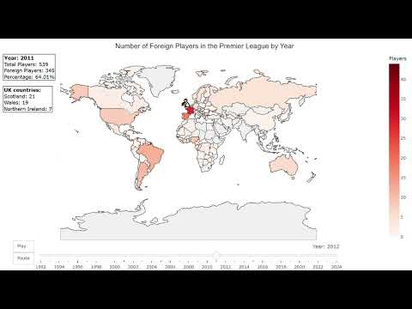

La Liga
La Liga, officially known as the Primera División, is Spain’s top professional football league. Established in 1929, it has played a major role in shaping European football history. Known for its technical and skilful playstyle, La Liga has hosted some of the greatest footballers ever, including Lionel Messi and Cristiano Ronaldo. Today, clubs like Real Madrid, Barcelona, and Atlético Madrid help maintain La Liga’s reputation as one of the most competitive and popular leagues in the world.
The following graphs shows the number and percentage of the top 10 foreign player nationalities playing in La Liga.
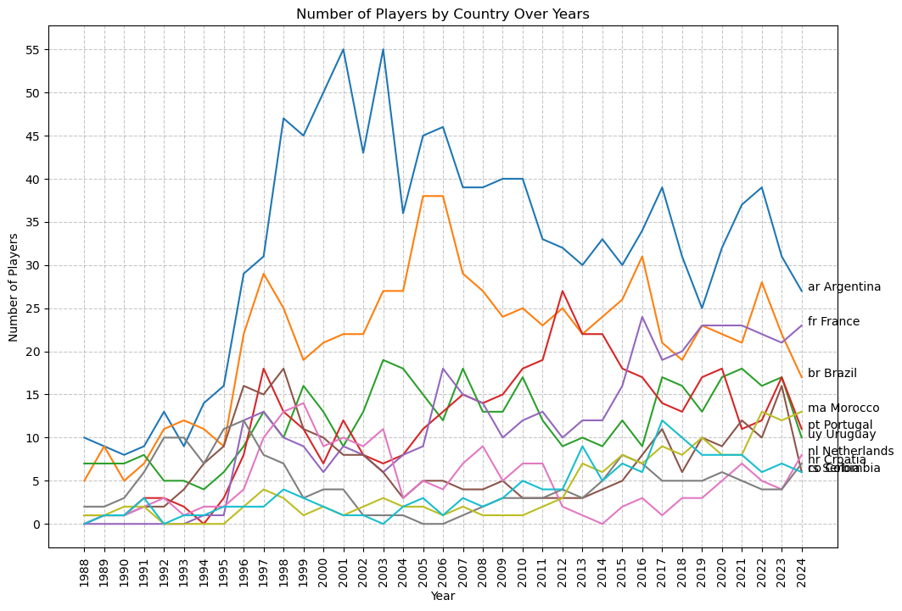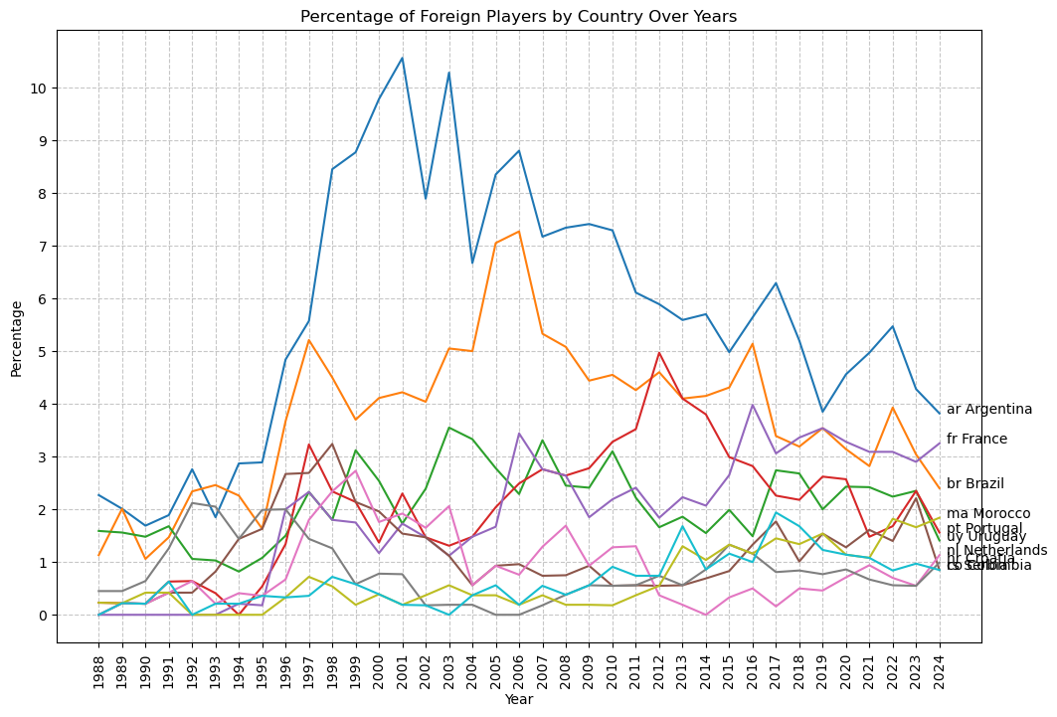
La Liga saw almost no non-Spanish imports before Bosman ’95, but within a few years Argentine and Brazilian stars exploded onto the scene. Argentina alone rose to over 50 players (≈11 % of squads) by 2002–03, with Brazil peaking near 30 (≈7 %). Uruguay and Colombia supplied a steady trickle, while France and Morocco contributed mid-decade surges via Atlético and Barça scouting. Argentine, Uruguayan and Colombian footballers all speak Spanish natively, smoothing communication, cultural adaptation and on-field cohesion as they integrate into La Liga squads.
Below is a video of the same graph, but with a world map. Countries in grey have never had players playing in La Liga.
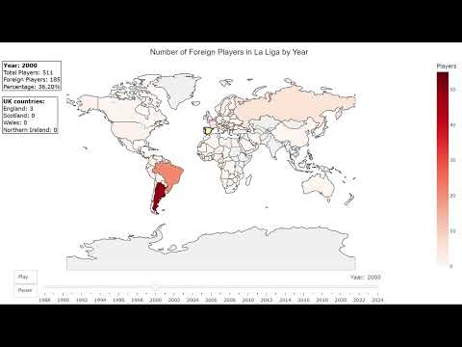

Serie A
Founded in 1929, Serie A has long been celebrated for its defensive rigor, tactical innovation and the global allure of its “big three”—Juventus, AC Milan and Inter Milan. The league’s golden era in the 1980s and ’90s drew record transfers and superstar managers, while its reputation for strategic depth endures today even as competition has broadened to clubs like Roma, Napoli and Atalanta.
The following graphs shows the number and percentage of top 10 foreign player nationalities playing in Serie A.
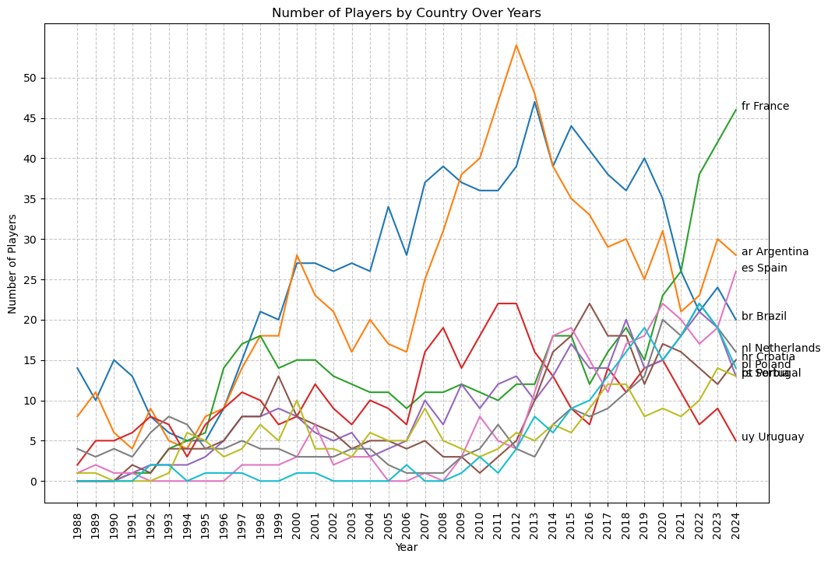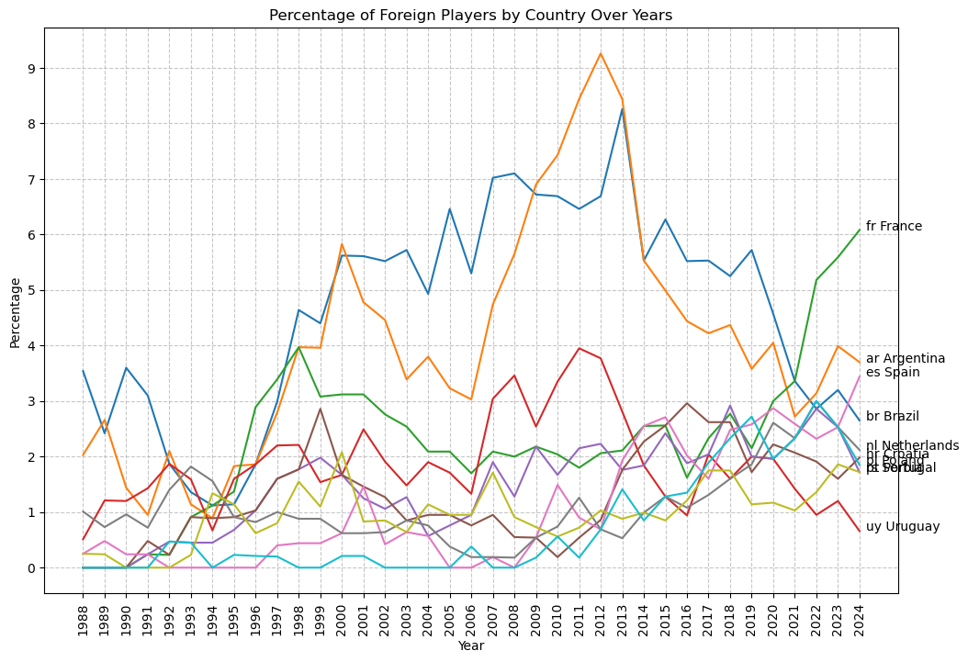
Argentine imports have historically led the way—rising from roughly 14 players in 1988 to peaks near 39–40 in the late 2000s—closely chased by Brazil, which surged to almost 48 players (≈9 % of squads) around 2013 before gradually tapering off. Southern and Eastern Europeans (Spain, Portugal, Poland) have steadily built their presence over the last decade, while the Netherlands and Croatia contribute a reliable trickle of technical talent. Most strikingly, France’s contingent has exploded since 2018, hitting 46 players (≈6 %) by 2024 and today standing as Serie A’s single largest foreign source.
Below is a video of the same graph, but with a world map. Countries in grey have never had players in Serie A.
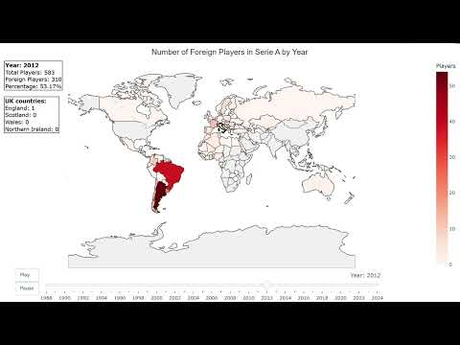

Bundesliga
Founded in 1963, the Bundesliga is famed for its high-octane atmospheres, the “50+1” fan-ownership rule and a system that fast-tracks youth talent into the first team. In its early decades, foreign signings were few and far between, but the 1995 Bosman ruling ushered in a new era of internationalisation.
The following graphs show the number and percentage of the top 10 foreign player nationalities in the Bundesliga.
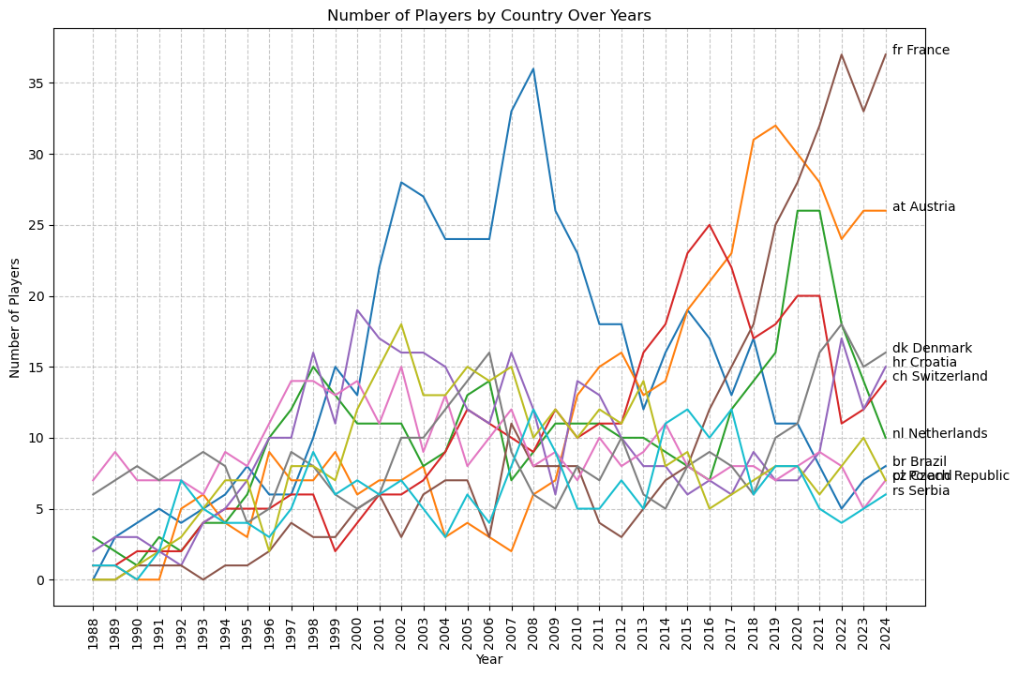
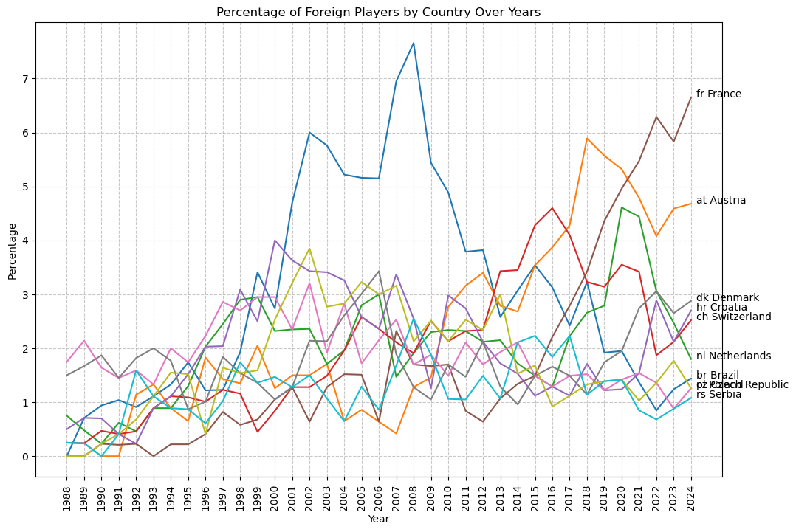
In 1988 there were fewer than 10 foreigners in the league; by 2002 that had jumped to roughly 28 players (≈6 % of squads), led by Denmark and Poland. A mid-2000s plateau near 35–36 players (≈7–8 %) saw Croatia and Switzerland break into the mix. The 2010s brought a surge from Austria—peaking above 30 players (≈5–6 %)—while long-standing feeders like the Netherlands, Brazil and Poland held steady at about 10–15 players (≈2–3 %). Most strikingly, France has exploded since 2018, contributing 37 players (≈6.7 %) in 2024 to become the Bundesliga’s single largest foreign source.
Below is a video of the same graph, but with a world map. Countries in grey have never had players in Serie A.
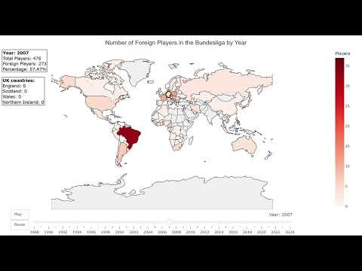

Ligue 1
Founded in 1932, Ligue 1 has long been a showcase for French flair—powered by Marseille, Saint-Étienne and, since the 2010s, Paris Saint-Germain and Monaco. Its deep scouting networks across Francophone Africa and a strong domestic youth system have shaped a very distinctive foreign-player mix.

The following graphs show the number and percentage of the top 10 foreign-player nationalities in Ligue 1.
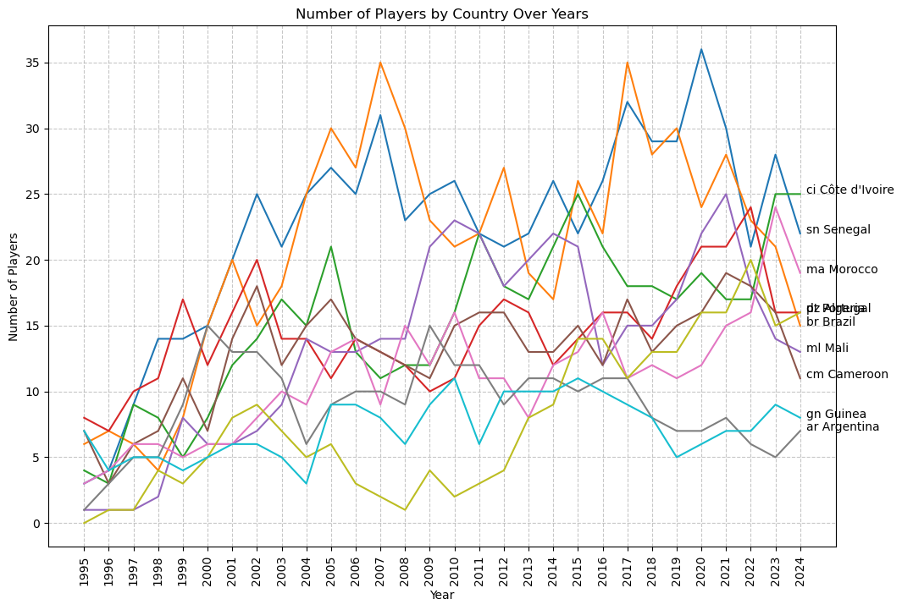
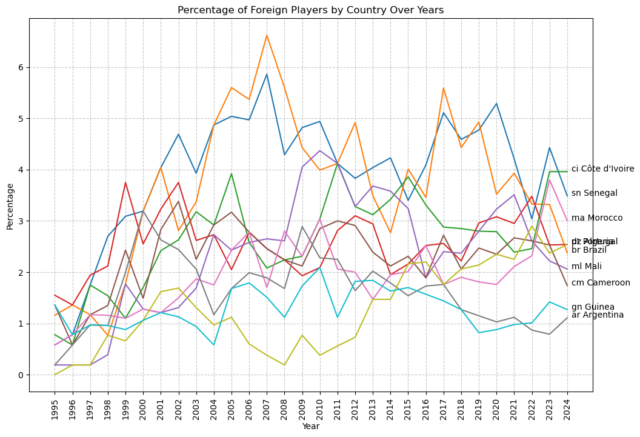
Ivorian talent dominates—rising from just 7 players in 1995 to a peak of about 36 in 2020–21 (≈5.2 % of all squad spots). Senegalese exports follow, climbing to roughly 25 players (≈3.7 %) in the late ’90s before settling around 20 (≈3 %). Morocco and Cameroon both enjoyed mid-2000s surges—Morocco hitting 21 (≈3 %) and Cameroon 17 (≈2.5 %)—and now contribute roughly 12–16 each (≈2–2.5 %). Brazil and Portugal supply a steady 12–15 players apiece (≈2–3 %), while Mali and Guinea appear intermittently with around 8–12 (≈1–2 %). This profile underlines Ligue 1’s role as the foremost gateway for Francophone African talent, complemented by consistent Portuguese and Brazilian signings.
Below is a video of the same graph, but with a world map shading each country by its total exports to Ligue 1. Countries in grey have never supplied players to the league.
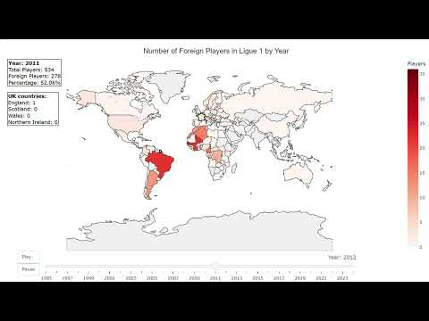

Big 5 combined
In the following graph, I’ve combined the foreign player counts from all 5 leagues, omitting each country’s domestic players.
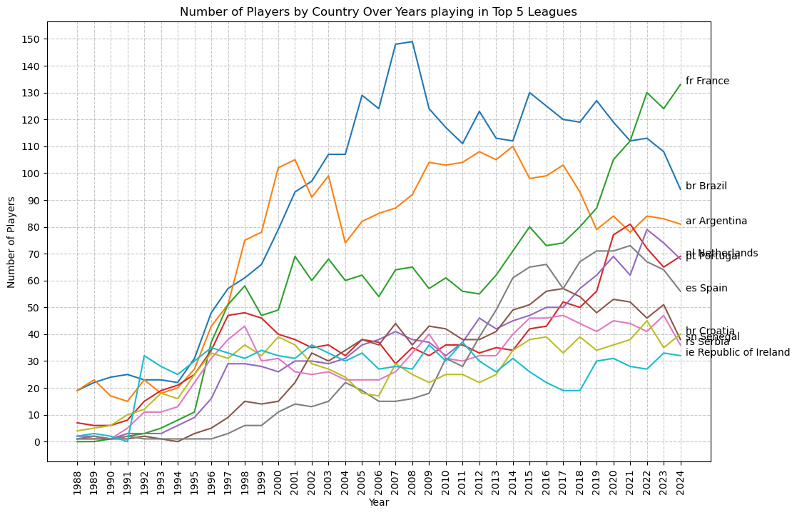
After the 1995 Bosman ruling, the total really takes off: you can see a sharp inflection as transfer barriers fell. Brazil’s contribution peaks around 2007–08 before gently sliding back, while Argentina dominates the 2010–15 window and then tapers off.
France stays relatively subdued until about 2019, when its exports surge past every other nation. A few reasons for this resurgence are:
- In 2020, Ligue 1 clubs gained the ability to offer five-year pro contracts to academy graduates. This gave the clubs an incentive to invest in youth development.
- France has done extremely well in tournaments, winning the world cup in 2018, and finishing second in the 2022 world cup & the 2016 Euro.
Most of the other pipelines—Portugal, the Netherlands, Poland, Croatia, Ireland, etc.—also trend steadily upward, reflecting clubs’ growing reliance on foreign talent and the ever-easier movement of players across Europe.
Below is a video of the same graph, but with a world map shading each country by its total exports to the Big 5 Countries in grey have never supplied players to the Big 5.
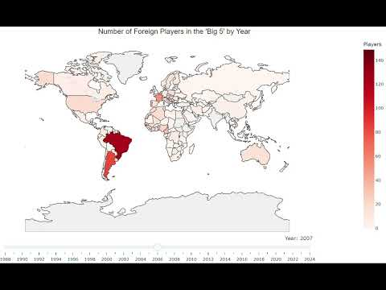

References
- FBref – comprehensive football stats and historical data: https://fbref.com/
- Transfermarkt –Player insights: https://www.transfermarkt.com/
- Wikipedia (“Association football players by nationality” category): https://en.wikipedia.org/wiki/Category:Association_football_players_by_nationality
- CIES Football Observatory, Monthly Report #85: “Global study of football expatriates (2017-2023)”: https://football-observatory.com/MonthlyReport85
- https://youtu.be/LctyvFaCdwA
- https://youtu.be/FFDZ-DD0dHg
- https://youtu.be/CY41Zgluqeo
- https://youtu.be/cWm6sRG_kDE
- https://youtu.be/XnMT2gfnWNA
- https://youtu.be/g--9-ETI4uc

